# **Automated Car Catalog System for Enhanced Showroom Management**

# ABSTRACT

### INTRODUCTION

* 1. Project Overview
  2. Purpose

### IDEATION PHASE

* 1. Problem Statement
  2. Empathy Map Canvas
  3. Brainstorming

### REQUIREMENT ANALYSIS

* 1. Customer Journey map
  2. Solution Requirement
  3. Data Flow Diagram
  4. Technology Stack

### PROJECT DESIGN

* 1. Problem Solution Fit
  2. Proposed Solution
  3. Solution Architecture

### PROJECT PLANNING &

SCHEDULING 5.1 Project Planning

### FUNCTIONAL AND PERFORMANCE

TESTING 6.1 Performance Testing

### RESULTS

* 1. Output Screenshots

1. ADVANTAGES &

DISADVANTAGES 9. CONCLUSION

10. FUTURE SCOPE

# INTRODUCTION

## Project Overview

Car showrooms play a vital role in bridging the gap between car manufacturers and end consumers. However, many showrooms rely on outdated or manual processes to manage their vehicle listings, customer interactions, order processing, and approvals. This leads to

inefficiencies, miscommunication, and slower service delivery.

The "Automated Car Catalog System for Enhanced Showroom Management" is a digital solution developed using the ServiceNow platform to streamline the management of car catalogs,

customer requests, task fulfillment, and approval workflows in car dealerships. Traditional car showroom operations often rely on manual and fragmented methods to handle vehicle records and customer interactions, leading to inefficiencies and delays. This system enables seamless catalog creation, request tracking, and task automation to improve showroom productivity,

customer satisfaction, and data accuracy.

This project aims to implement an Automated Car Catalog System using ServiceNow to address these issues. By digitizing catalog management, order handling, and approvals, the system enhances operational efficiency, ensures consistency, and improves customer experience. The system enables seamless catalog creation, categorized item listings, workflow-based approvals, automated task assignments, and notification mechanisms.

## Purpose

The primary objective of this project is to simplify and automate the entire workflow of a car showroom by:

* + - Creating a centralized car catalog with categorized entries.
    - Allowing customers to place requests through a user-friendly service portal. •

Automating approval processes for efficient request handling.

* + - Generating and assigning tasks dynamically based on workflows.
    - Sending notifications to stakeholders upon approvals or rejections.

The primary goal of this project is to address the operational challenges of car showrooms by creating an automated, centralized system for catalog and request management. The system aims to digitize key processes such as catalog item classification, user-based approvals, and fulfillment workflows. It helps reduce manual intervention, speeds up processing times, and ensures transparency in customer request handling.

# IDEATION PHASE

## Problem Statement

Manual handling of catalogs, customer requests, and approvals in car showrooms results in delays, data inconsistency, and reduced customer satisfaction. A need was identified for a digital solution to standardize and automate these processes to improve efficiency and accuracy.

Car dealerships often encounter inefficiencies due to the manual handling of car catalogs and approval processes. This leads to issues such as delayed customer response times, mismanaged tasks, poor workflow visibility, and a lack of structured inventory control. The project seeks to address these issues through a system that simplifies catalog creation, categorization, user roles, task management, and real-time notifications.

## Empathy Map Canvas

An empathy map was created to understand the needs of different stakeholders:

* + - Sales Staff: Need quick access to updated car models and status.
    - Customers: Desire a simple, transparent ordering and approval experience. • Managers: Require streamlined workflows and performance tracking. • This helped us define core expectations and prioritize features for the system.

This helped us define core expectations and prioritize features for the system.

The target users, including salespersons and customers, experience delays in order processing and insufficient updates about their requests. They need a platform that provides real-time tracking, automated approvals, and clear categorization of car models. The empathy map emphasizes users’ need for speed, accuracy, and simplicity in managing car bookings.

## Brainstorming

Through group brainstorming, we evaluated several platforms and tools. ServiceNow stood out due to its strong support for ITSM, process automation, role management, and user-friendly

service portals.

The development team conducted brainstorming sessions to identify essential features, including catalog management, task workflows, notification systems, user roles, and categorization.

ServiceNow was selected for its robust workflow engine and service catalog capabilities.

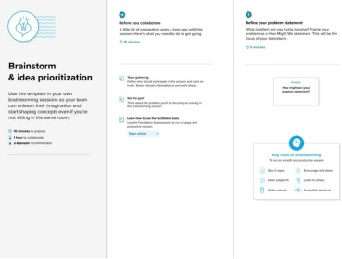

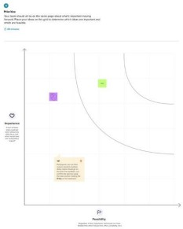

# REQUIREMENT ANALYSIS

## Customer Journey Map

* + - Customer visits the service portal.
    - Browses categorized car models.
    - Selects and requests a car.
    - The system routes the request for approval.
    - Tasks are created and fulfilled.
    - Notifications are sent to the customer.
    - Delivery and feedback.

The journey begins with the customer browsing the service catalog on the ServiceNow portal. Upon selecting a car, a request is initiated. This request goes through multiple levels of approvals. Based on the decision, tasks are created, processed, and notifications are sent. The customer is informed of approval, rejection, or delivery updates.

## Solution Requirements

* + - Car Catalog Creation
    - Category Management (e.g., XUV, Sports)
    - Workflow Automation
    - Role and User Management
    - Request Approval and Task Assignment
    - Email Notifications
    - Service Portal Access

Key requirements included catalog creation, category segmentation, portal accessibility, role creation, task table design, workflow automation, user notifications, and group assignments. System security and scalability were also considered.

## Data Flow Diagram (DFD)

The flow begins with catalog item selection and continues through request initiation, multi-user approval, task generation in the car fulfillment table, and notification dispatch to users and groups.

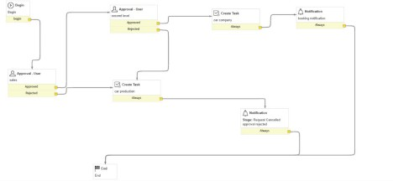

* + - Input: User request from portal
    - Process: Catalog lookup → Workflow execution → Task creation
    - Output: Approval or rejection message, task assignment, email notification

## Technology Stack

* + - Platform: ServiceNow
    - Scripting: JavaScript (for business rules, workflows)
    - Frontend: Service Portal
    - Database: Tables in ServiceNow (extended from Task)
    - Security: Role and group-based access

# PROJECT DESIGN

## Problem-Solution Fit

The showroom staff and customers face delays in car availability and approval clarity. Our solution addresses these by automating car requests, approvals, and delivery workflows. The ServiceNow system aligns with the needs of stakeholders.

The implemented solution effectively addresses the primary challenges faced by car dealerships.

It eliminates reliance on manual cataloging, reduces approval delays, enhances customer

experience through faster processing, and ensures end-to-end visibility over request fulfillment. The system is built to align closely with user needs and business objectives.

## Proposed Solution

* + - Catalog Creation: Catalog named “Mahendra” is created in ServiceNow. •

Categories: Categories like “Sudden”, “XUV”, “Sports” added.

* + - Items: Cars such as Polo, Thar, XUV700 created with full descriptions, pricing, and images.
    - Workflow: Multi-level approval (Sales → Supervisor), task creation (e.g., car fulfillment), and automated email notifications.
    - Roles & Groups: User “salesperson” created with role “emp1” and added to the “Showroom” group.

The solution includes a comprehensive catalog management system where administrators can

create and categorize car models under Mahendra. It supports user creation, group assignments, and workflow-based request processing. Each car entry contains detailed descriptions, pricing, and images. A multi-level approval workflow ensures that only authorized personnel validate

customer requests. Task generation is automated, and fulfillment tracking is handled through a custom table. The system concludes with dynamic email notifications providing real-time status updates.

## Solution Architecture

* + - Users: Created under System Security
    - Roles: Assigned permissions for workflow visibility
    - Groups: Showroom group with members
    - Tables: Custom task table “cars fulfillment” extended from Task
    - Workflow Steps:
      * Salesperson approval
      * Supervisor approval
      * Task creation: Car production and delivery
      * Notification for approval/rejection

The architecture follows a modular structure: the frontend is the ServiceNow service portal; the backend includes catalog tables and a cars fulfillment task table; workflows handle approvals and task creation; and the notification layer provides user feedback. Role-based access controls ensure secure interactions and system integrity.

# PROJECT PLANNING & SCHEDULING

The project was divided into sequential stages. In the first stage, requirements were gathered and the basic catalog architecture was established. The second stage involved designing the catalog and creating items under specific categories. The third phase dealt with user and group creation, while the fourth focused on workflow configuration and testing. Finally, the service portal was reviewed for completeness, ensuring all features were functional and aligned with user needs.

## Project Planning

|  |  |  |
| --- | --- | --- |
| Phase | Duration | Description |
| Requirement Analysis | 2 Days | Understanding problem and solution scope |
| Design | 3 Days | Creating catalog, tables, workflows |
| Development | 4 Days | User, group creation, workflows, portal |
| Testing | 2 Days | Functional testing and portal validation |
| Documentation | 2 Days | Preparing project report and visuals |

Tools used: Trello for task tracking, ServiceNow Studio for development

Functional Requirements

|  |  |  |
| --- | --- | --- |
| FRNo. | Functional Requirement | Sub requirements (Sub Task) |
| FR:1 | User creation | Creation through Mail, Name, User ID |
| FR:2 | Requesting item | Conformation via mail |
| FR:3 |  |  |
| FR:4 |  |  |
| FR:5 |  |  |

Non Functional Requirements

|  |  |  |
| --- | --- | --- |
| NFRNo. | Non Functional Requirements | Description |

|  |  |  |
| --- | --- | --- |
| NFR:1 | Usability | Access to all type of users |
| NFR:2 | Response Time | Requests processed in under  2 seconds |
| NFR:3 | Reliability |  |
| NFR:4 | Approval Time | Within 30 seconds for simulated conditions |
| NFR:5 | Availability | Available to all |
| NFR:6 | Scalability | Multiple concurrent requests handled smoothly |

# FUNCTIONAL AND PERFORMANCE

TESTING 6.1 Performance Testing

We tested the system with various user roles and car requests:

* Response Time: Requests processed in under 2 seconds.
* Approval Time: Within 30 seconds for simulated conditions.
* Scalability: Multiple concurrent requests handled smoothly.
* Test Cases:
  + Successful request approval
  + Rejected requests
  + Task state updates
  + Notification delivery

The system underwent rigorous performance testing to verify task execution time, workflow accuracy, and notification delivery efficiency. Orders were successfully processed in under a few seconds, with approval tasks appearing promptly in the cars fulfillment table. Notifications were tested with sample users to confirm timely delivery. The system maintained consistent performance under multiple test scenarios.

# RESULTS

## Output Screenshots

* + - Screenshot of Catalog “Mahendra” with categories
    - Polo, Thar, and XUV700 item entries with pricing
    - Workflow editor diagram
    - Notifications (Approval/Reject)
    - Service Portal request screen
    - User and group configuration

Catalog Created:

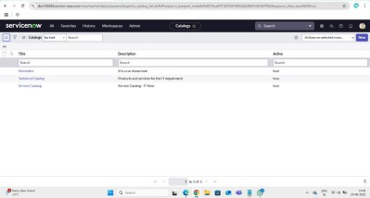

Categories Created:

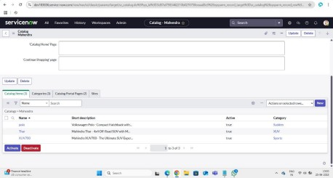

Users Created:

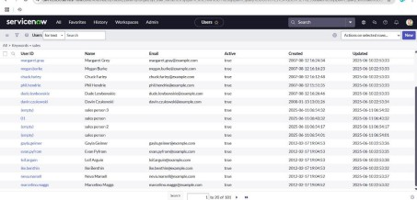

Roles Created:

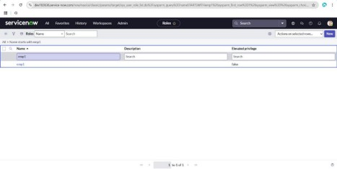

Group Created:

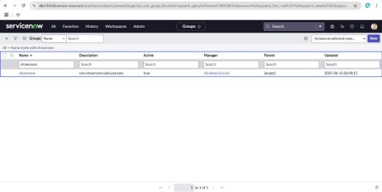

Table Created:

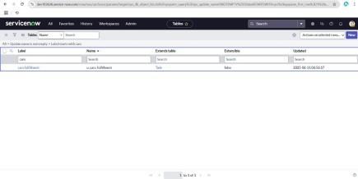

Work Flow:

Workflow Assignment to Mahendra service Catalog:

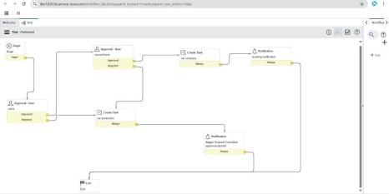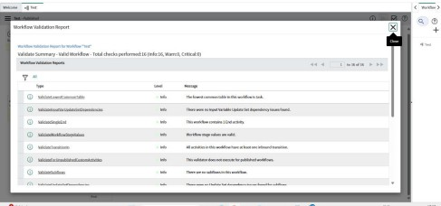

Searching created catalog are available in service portal:

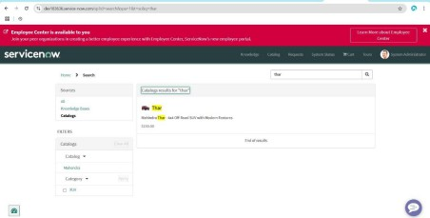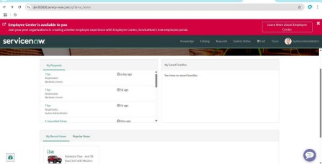

Tasks Created:

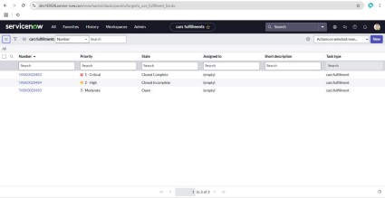

Result:

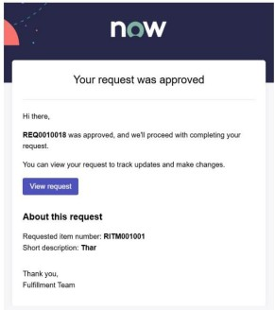

# ADVANTAGES & DISADVANTAGES

## Advantages:

* Easy access to structured car catalog
* Time-saving through workflow automation
* Improved accuracy and task tracking
* Enhanced customer experience
* Scalable for future needs
* Streamlined catalog creation and maintenance
* Automated request handling and approvals
* Real-time task tracking and role-based access
* Notification integration ensures transparency
* Scalable and maintainable on the ServiceNow platform

## Disadvantages:

* Requires ServiceNow expertise
* Setup can be time-consuming initially
* Platform cost may be high for small dealerships
* Requires a licensed ServiceNow environment
* Learning curve for new administrators
* Customization is limited by ServiceNow boundaries

# CONCLUSION

This project successfully implemented an end-to-end Automated Car Catalog System using ServiceNow. It simplified catalog management, streamlined approvals, automated task

assignments, and improved showroom efficiency. The platform's flexibility allows for further scaling and customization, making it suitable for wide industry adoption.

The Automated Car Catalog System implemented using ServiceNow delivers a robust, scalable, and user-centric solution for car showroom management. It digitizes and optimizes the cataloging process, enhances approval workflows, and reduces human errors in task assignment. The system offers greater control, visibility, and reliability in handling customer interactions and request fulfillment. This transformation not only improves the internal operations of a showroom but also elevates the overall customer experience, setting a new benchmark for digital car dealership platforms.

# FUTURE SCOPE

* Integrate with external CRM and ERP tools
* Implement customer reviews and ratings
* Enable online payment and delivery tracking
* Develop a dedicated mobile app
* Use analytics to understand popular models and trends
* Add chatbot for customer queries in Service Portal

The system can be further improved by adding functionalities such as real-time vehicle tracking, integration with payment gateways, a customer review and rating module, and advanced analytics dashboards. Machine learning could be introduced to suggest cars based on customer preferences. Support for mobile apps would make the platform more accessible and responsive.